HARVARD UNIVERSITY
Faculty of Arts and Sciences
Office of International Education
1414 Massachusetts Ave. 3rd floor
Cambridge, MA 02138

TDS Helpline:  617.496.2722 |  | Questions about TDS?  Email: oie@fas.harvard.edu

Terra Dotta Software (TDS) for Study Abroad
studyabroad.fas.harvard.edu

Quick Reference Guide for Concentration Advisers

TDS for Study Abroad, formally known as StudioAbroad, is the on-line system used by students to apply for Harvard degree credit for term-time study abroad. Administrators and faculty use TDS to approve concentration and elective credit. (Please note: the course approval process for summer transfer credit is done on paper.)

There are 3 phases of TDS:
- Pre-Decision (before students leave campus)
- Abroad (when students are abroad)
- Return (when students return to campus)

Applications have a status coinciding with these 3 phases. They are called:
- New
- Abroad
- Return

PRE-DECISION PHASE (students on campus, pre-departure)

As part of their on-line application for credit, students are asked to print out one form that will require your signature. This process is designed to ensure you have the opportunity to meet with concentrators planning to study abroad.

- This form (Approval of Term-Time Study Abroad) lists suggested and/or tentative courses only. Students will make final course selections once abroad, during the add-drop period of their study abroad program.

- Students are required to meet with you first to receive your approval and signature. They schedule an additional mandatory meeting with their Allston Burr Resident Dean after meeting with you.

- After students receive both your approval and signature, and the Allston Burr Resident Dean’s, they are instructed to return the form to the Office of International Education.

- It is not necessary to access the on-line system prior to students’ departures!

ABROAD PHASE (while students are abroad)

When students are in their add-drop period abroad, they select courses and fill out the on-line Abroad Course Enrollment form. When your concentrators request concentration credit, you will be notified via email by the on-line system. Please note: this email will contain step-by-step instructions on how to pre-approve abroad courses.

1) Log in to TDS [studyabroad.fas.harvard.edu]. Then, click on “LOGIN” in the right-hand corner, and authenticate through HarvardKey.

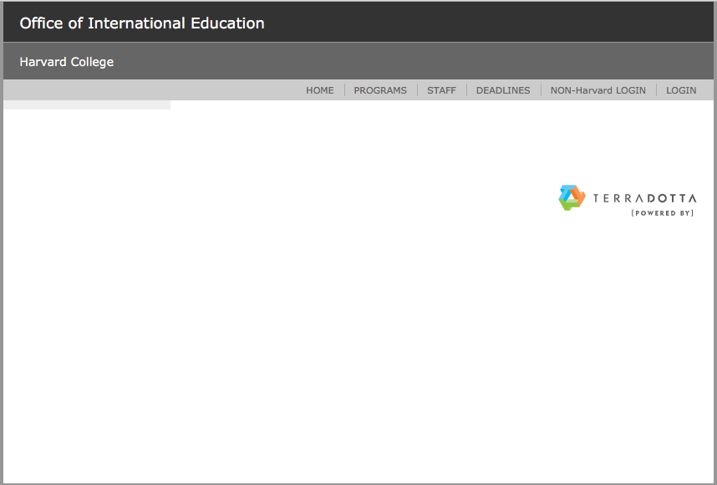

2) Click on Shared Queries. (Queries will be set up by OIE.)

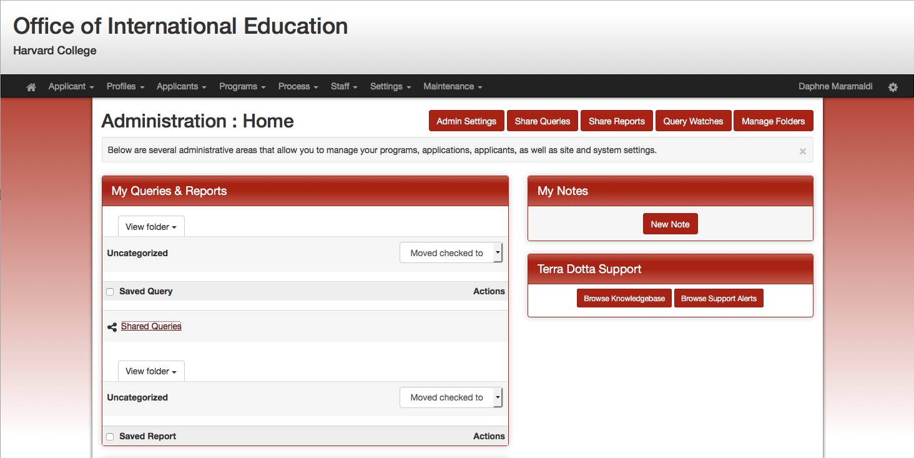

3) Click on the shared query entitled “[Name of Concentration], Status: Abroad, Concentration PRE-approval needed.” You will see a list of your concentrators who are requesting concentration credit. (Below “TEST” replaces the name of the concentration.)

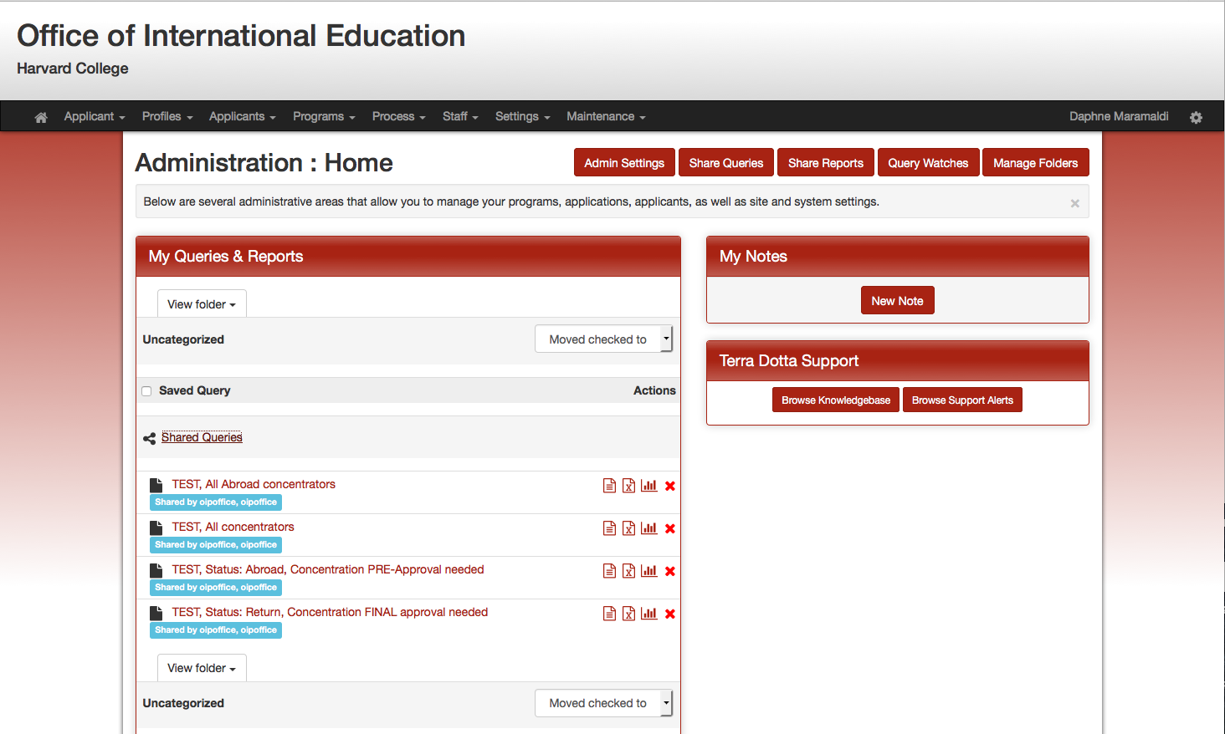
4) Click on the student application.

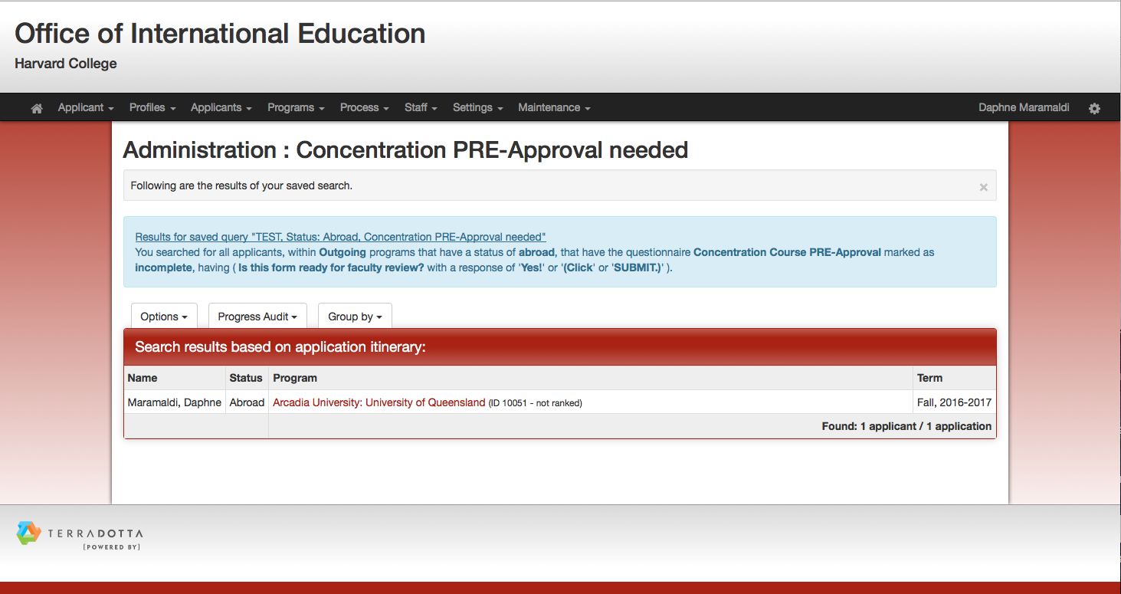

5) Click on the Questionnaires tab.

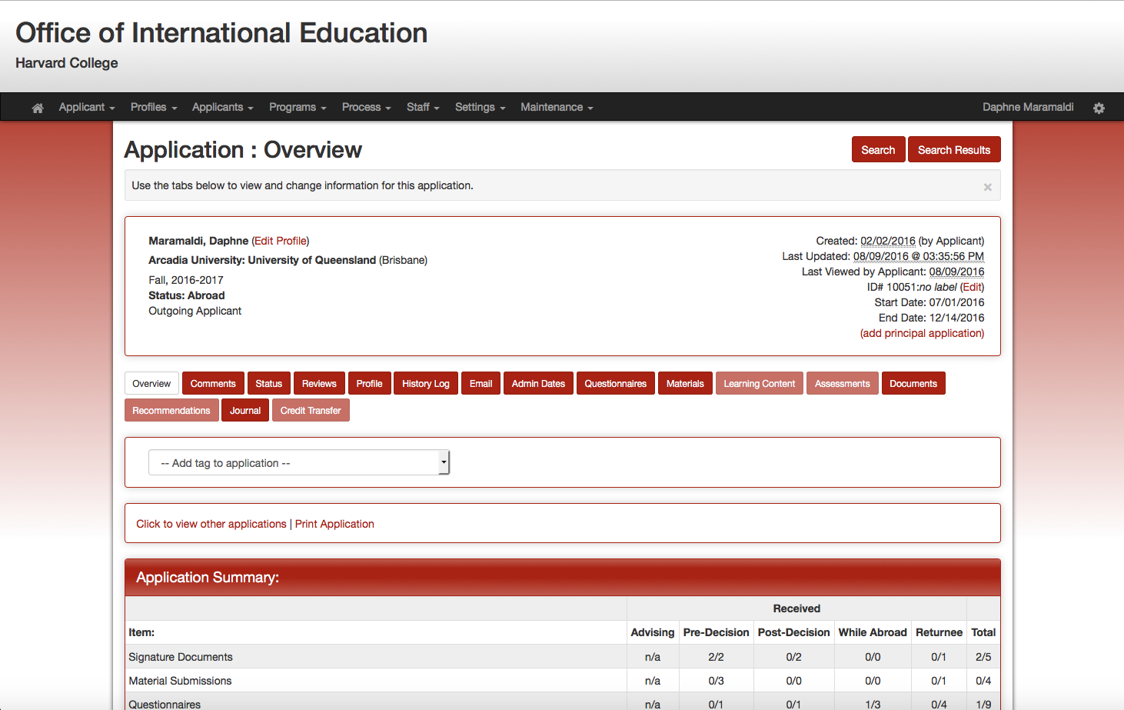

6) Under the While Abroad red banner, click on "Abroad Course Enrollment.”

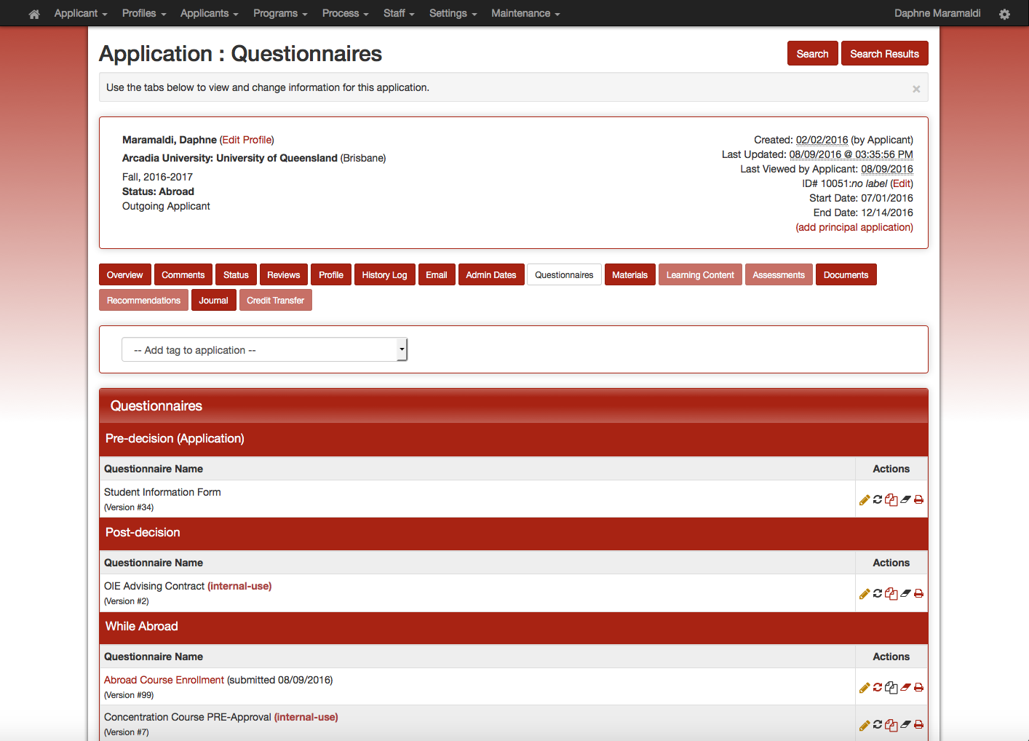

7) Students are required to provide all relevant information (such as course descriptions, translated syllabi, allotted credit, contact hours, etc.) Please review the course(s) your concentrator seeks pre-approval for concentration credit.

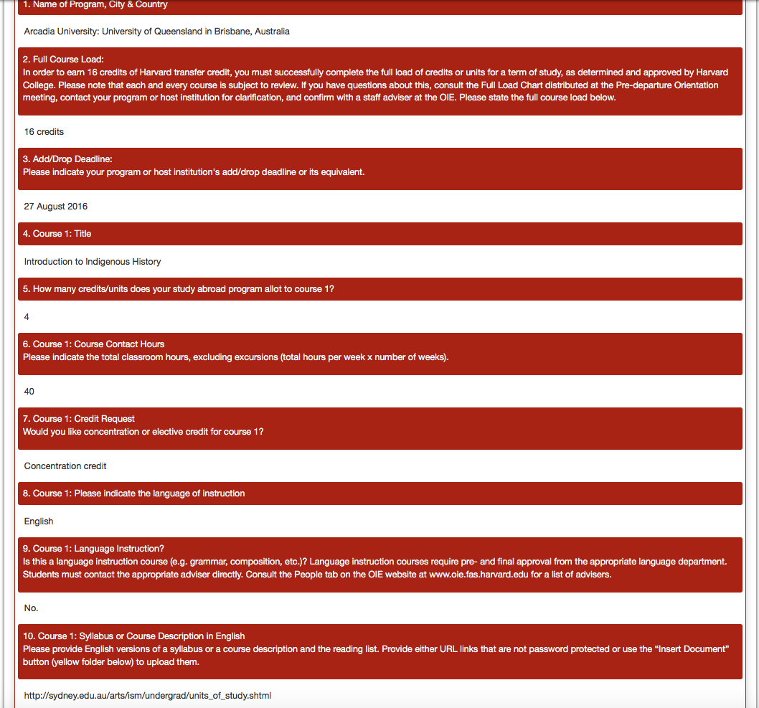

NEW: After reviewing each course, you may grant PRE-approval, FINAL approval or deny credit for each course.
- If you are granting PRE-approval you will be asked to provide final approval once the term has concluded and the student’s abroad transcript has been received.
- If you are granting FINAL approval, you will not be asked to review the transcript when it arrives and approve the course again. Instead, the Director of OIE will review course transcripts for accuracy and grading, taking care to apply any contingencies required for concentration transfer credit, which may be indicated on the form “Concentration Course ABROAD approval.”

8) To grant PRE-approval , FINAL approval and/or deny credit, go back to the Questionnaires tab.
9) Under the While Abroad banner, click on the EDIT pencil to the right of “Concentration Course ABROAD approval.”

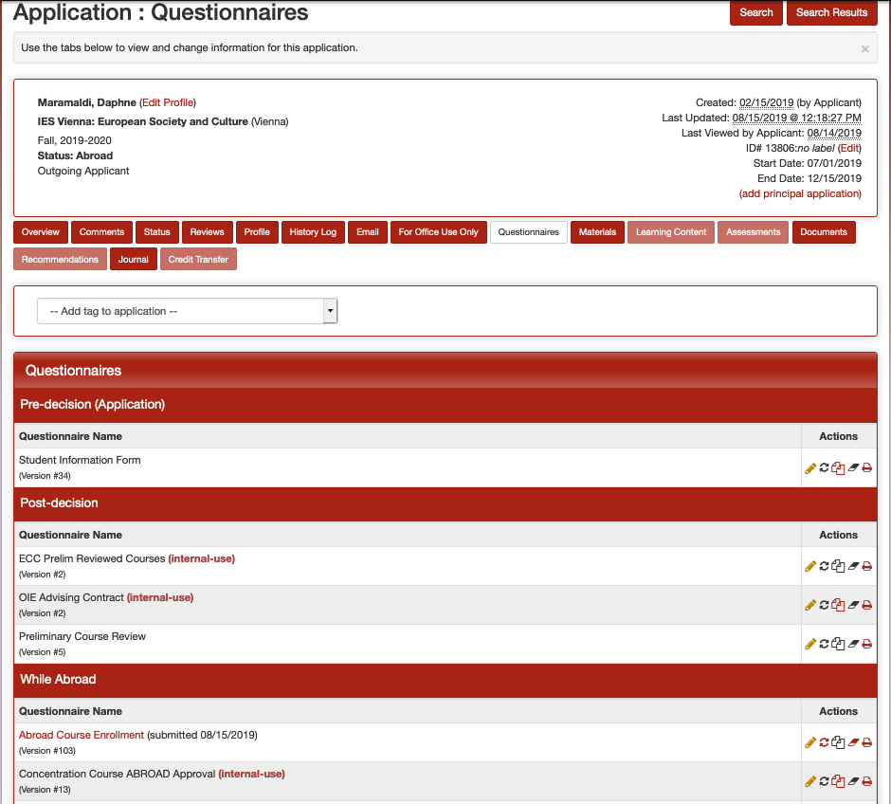

10) Complete the relevant questions. Please make sure to list the reviewed course titles, and any other relevant information regarding approval or denial. Also, note that students are NOT able to view this approval form. Although it is only seen by administrators, it becomes part of the student’s record. Thus, it can be subpoenaed in a court of law.

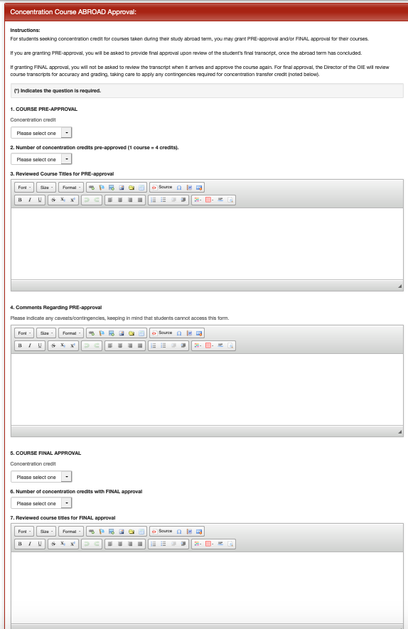
OR
FINAL approval
PRE-approval

11) Click on the Submit button.

Note: If you instruct the student to upload more information onto the Abroad Course Enrollment form, use the “un-submit” button (red arrows icon) to the right of his/her Abroad Course Enrollment form. This will unlock the application and enable the student to resubmit materials.

RETURN PHASE (when students return)

After students have returned to Cambridge, their abroad transcript has been processed, and if you did not grant FINAL approval in the Abroad phase, you will be notified by the system via email. Please note: this email will give you step-by-step instructions on how to give FINAL approval for abroad coursework.
1) Log in to TDS [studyabroad.fas.harvard.edu]. Then click on “LOGIN” in the right hand corner, and authenticate through HarvardKey.
2) Click on Shared Queries (set up by OIE).
3) Click on the query entitled “[Name of Concentration], Status: Return, Concentration FINAL approval needed.” You will see a list of students whose transcripts have arrived and who are requesting FINAL approval for concentration credit. (Below “TEST” replaces the name of the concentration.)

4) Click on the student’s application.
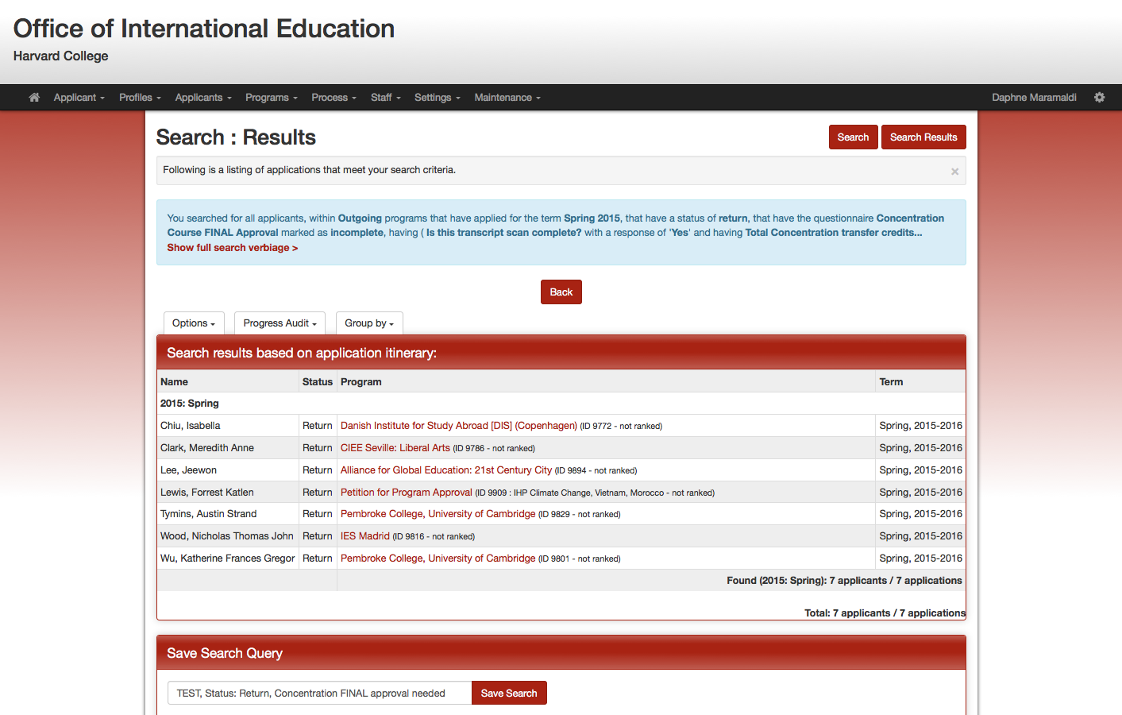
5) Go to the Questionnaires tab. 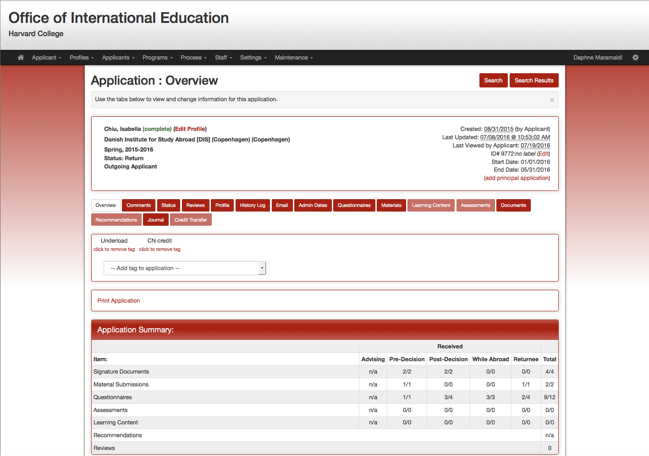

6) Under the Returnee red banner, click on "Student Transcript."

7) Review their courses and grades.
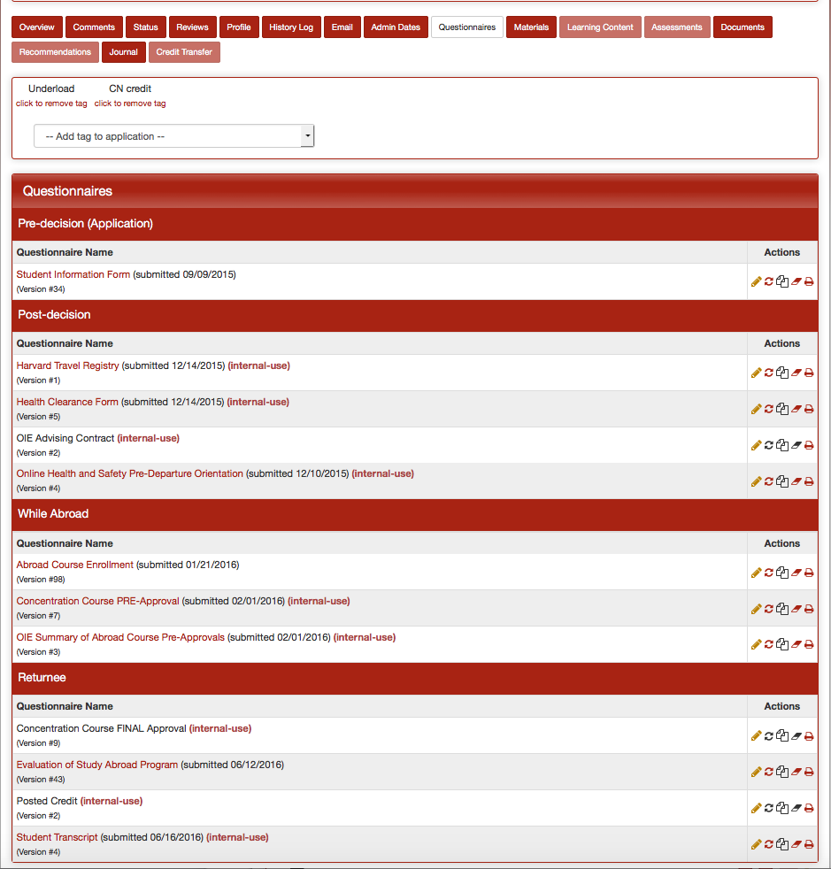

Note: If you want to be reminded of the courses you pre-approved for concentration credit, leave the transcript open and return to the Questionnaires tab. Under the While Abroad banner, click on "Concentration Course ABROAD Approval" to view the pre-approved courses.

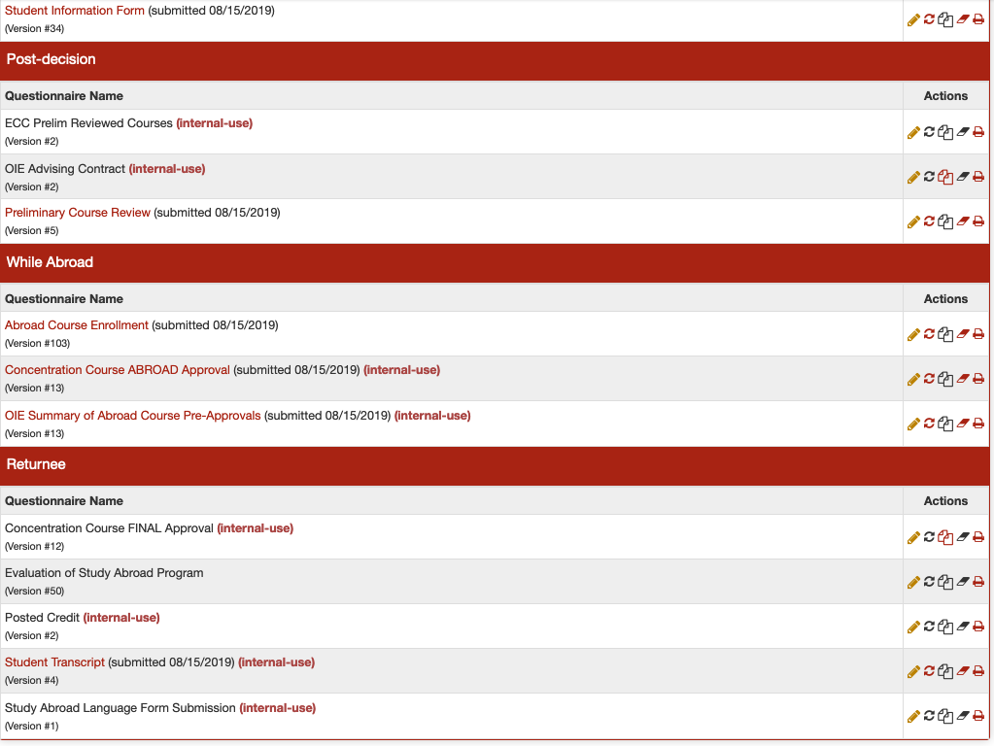

8) To approve or deny, use the Questionnaires tab.
9) Under the Returnee banner, click on the EDIT pencil to the right of “Concentration course FINAL approval.”

10) Complete the form.

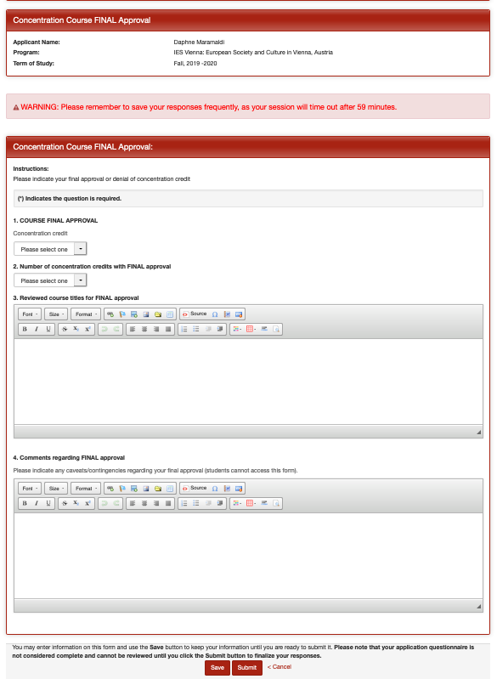
11) Click on Submit button.

Features to Keep in Mind

Tabs under the student’s name on the Overview page:

- Profile: This holds all the student demographic information, relative to the College, such as House, Concentration, etc.

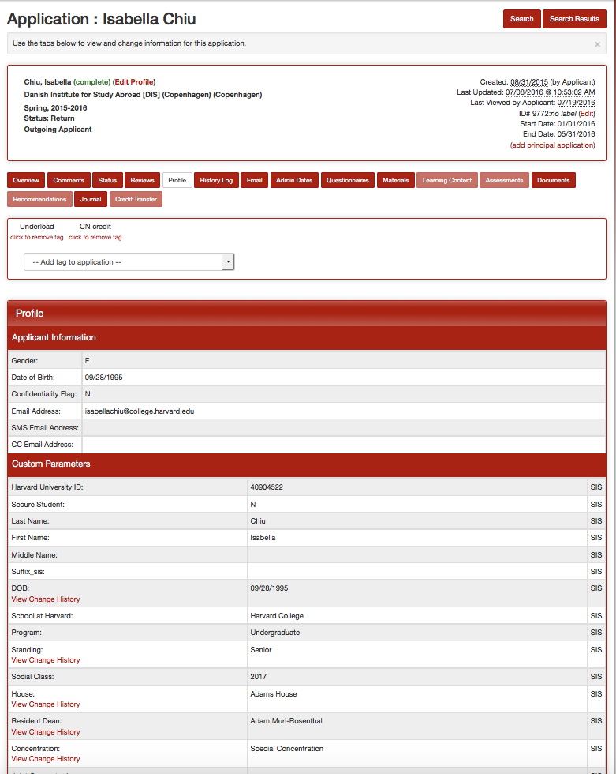
History Log: This documents all the activity on the application, recording the date and the person who has made changes to the application.

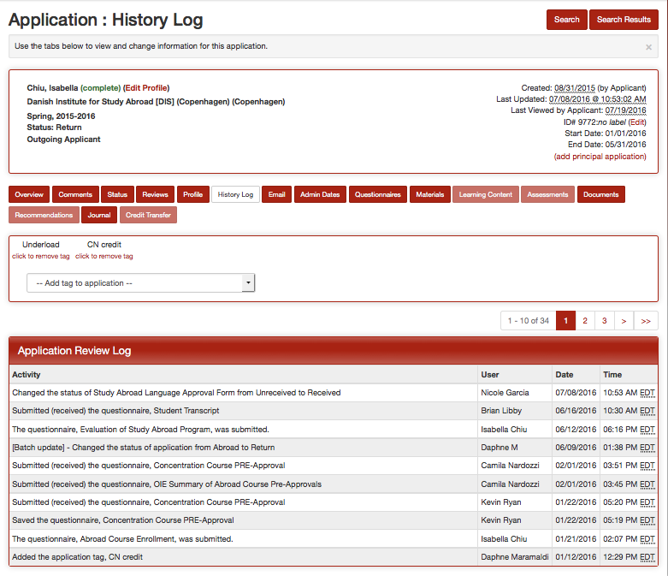

Lastly, when viewing list of students, it is easy to group them by program name, program location or abroad term, with a simple drop down menu.

